Python Doctor Appointment Booking System

- Background/ Problem Statement

If anybody is ill and wants to visit a doctor for a check-up, he or she needs to visit the hospital and wait until the doctor is available. The patient also waits in a queue while getting an appointment. If the doctor cancels the appointment for some emergency reasons then the patient is not able to know about the cancellation of the appointment unless or until he or she visits the hospital. This becomes tedious for all the involved individuals.
Our Python-Based Doctor Appointment Booking System is designed to overcome the issue of managing and booking appointments. The system provides patients or any user with an easy way of booking a doctor’s appointment online. It also offers an effective solution where users can view various booking slots available and select the preferred date and time.
In this project, the front end involves Html, CSS and JavaScript and the back end involves Python. The database: used is MySQL Database and Django is used for the framework.

- Working of the Project

This python-based project consists of three modules, including Admin, Doctor and Patient.

The admin can log in using their credentials. They have the access to add, update, delete and view doctors. By using patient IDs and names, they can also see patient details and past treatments. The admin can view the appointment details by filtering the dates. They can also check the feedback given by the patients.

The doctor can log in using their credentials. They can manage their profile and change the password if they want. They can view any appointment details by filtering the dates. If they want to look for any particular patient, they can search for the patient’s name or ID. They can view all the details about the patients and also about their past treatment. They can also add treatments for their patients.

To log into the system, the patient would need to register first. After logging in, the patient can manage their profile and change the password. They can book an appointment with a doctor by choosing the doctor, date and slots. They can view all the appointments in the booking history. They can even cancel bookings any time they want. They can search for doctors by their name, type or locality. They can view the doctor’s details. They can also give feedback to the admin. They can view the treatment details added by the doctors.

- Advantages

- The system is easy to maintain.
- It is user-friendly.
- It helps to book doctor’s appointments easily and efficiently.
- Patients can book appointments from the comfort of their homes.
- It can help to reduce patient absenteeism.

- System Description

The system comprises 2 major modules with their sub-modules as follows:
- Admin:
● Login:
- The admin can log in using their credentials.
● Manage Doctor:
- The admin can add, update, delete and view doctors’ details.
● View Patients:
- The admin can search patients by their name and patient Id.
- They can view the patients’ details and their past treatments.
● View Appointments:
- The admin can view the appointment details by filtering the dates.
● View Feedback:
- They can also view the feedback given by patients.

- Doctor:
● Login:
- The doctor can log in using their credentials.
● Profile:
- The doctor can manage their profile.
● Change Password:
- They can change their passwords if they want.
● View Appointments:
- The doctor can view the appointment details by filtering the dates.
- They can also view patient details and their past treatments.
- They can add treatment for their patients.
● View Patients
- The doctor can search for patients by their names or patient Ids.
- They can view patient details and their past treatments.

- Patient:
● Register:
- The patient would need to register first to log in.
● Login:
- The patient can log in after registering.
● Profile:
- They can manage their profile.
● Change Password:
- They can change their password if they want.
● New Booking:
- The patient can choose the doctor, date and slot.
- After making all the selections, they can book an appointment.
● Booking History:
- The patient can view all their appointments here.
- They can cancel bookings anytime they want.
● Search Doctor:
- The patient can search doctors by their name, type and locality.
- They can view the doctors’ details.
● Feedback
- They can give feedback to Admin.
● Treatments:
- The patient can view treatments and the details added by doctors.

- Project Life Cycle

The waterfall model is a classical model used in the system development life cycle to create a system with a linear and sequential approach. It is termed a waterfall because the model develops systematically from one phase to another in a downward fashion. The waterfall approach does not define the process to go back to the previous phase to handle changes in requirements. The waterfall approach is the earliest approach that was used for software development.

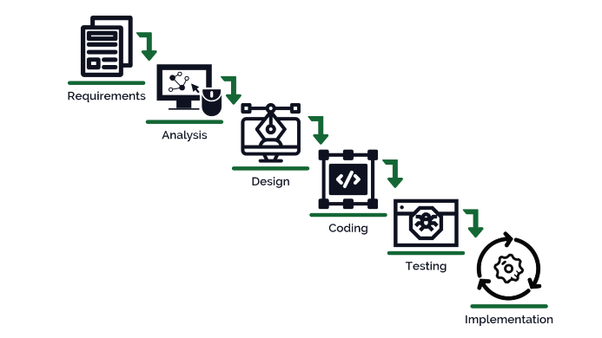

- System Requirements

- Hardware Requirement

- Laptop or PC
- Windows 7 or higher
- I3 processor system or higher
- 4 GB RAM or higher
- 100 GB ROM or higher

- Software Requirement

- Laptop or PC
- Python
- Sublime Text Editor
- XAMP Server

- Limitations/Disadvantages

- The patient cannot change the slot or date once booked.
- It requires a large database.

- Application –

- The system provides patients or any user with an easy way of booking a doctor’s appointment online.

- Reference

- https://www.jetir.org/papers/JETIR2005455.pdf
- https://www.academia.edu/26066176/Design_and_Development_of_Online_Doctor_Appointment_System
- https://ijcrt.org/papers/IJCRT1812133.pdf
- https://arxiv.org/ftp/arxiv/papers/1701/1701.08786.pdf

